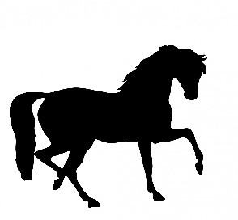
MEDINA MIDDLE SCHOOL
PBIS KICK-OFF WEEK
Monday 8/28 | Tuesday 8/29 | Wednesday 8/30 | Thursday 8/31 | Friday 9/1
Be  Safe  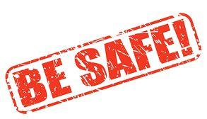 | 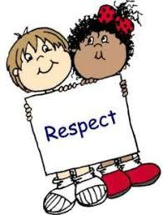  Be Respectful |   Be Productive | 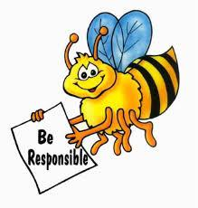  Be Responsible | The Medina Way  Medina Spirit Day  Throughout the day, show you know The Medina Way by being Safe, Respectful, Productive & Responsible and by wearing school colors: Green, Black & White

Every morning during Mustang Live, Staff & Students will learn about the building wide expectations known as ‘The Medina Way’

